Supplementary Information (SI)
Title: Cross-Domain Fairness Transferability and Biomechanical Noise Bias in Multi-Label Continuous ECG Diagnosis
Author: Chuelwon Lee
Affiliation: RAQA Team, HUINNO Co., Ltd., Seoul, Republic of Korea
Corresponding Email: this14@naver.com

Section S1. Additional Visualization Figures
Figure S1. QRS Duration Analysis Across Demographic Subgroups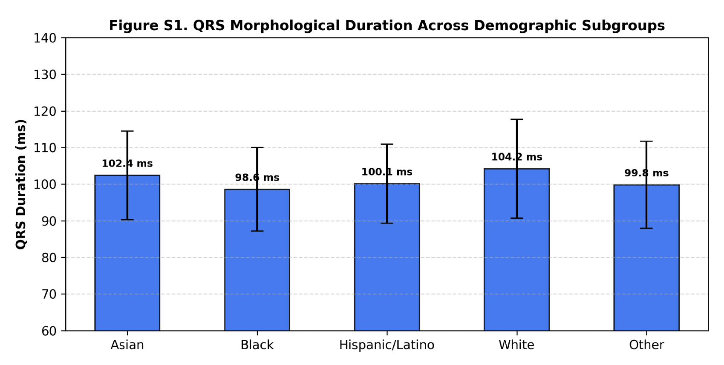
Caption: Distribution of QRS duration (ms) extracted from the MIMIC-IV-ECG cohort disaggregated by demographic subgroups. The morphological variations in ventricular depolarization duration account for biomechanical signal baseline variations when reducing 12-lead signals to a single Lead II continuous patch setup.

Figure S2. Explainable AI (XAI) Grad-CAM Visualizations Under Biomechanical Noise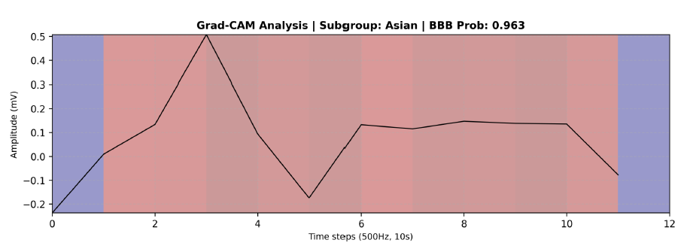
Caption: Gradient-weighted Class Activation Mapping (Grad-CAM) comparison between (A) Clean 12-lead ECG signals and (B) 1-lead continuous patch signals superimposed with NSTDB motion artifacts ($σ=0.15$). The attention heatmap illustrates feature drift caused by noise perturbation, explaining the disproportionate sensitivity drop in minority subgroups.

Section S2. Core Algorithmic Code Implementation
Code Snippet S1. Noise-Aware Fairness Transfer (NAFT) Composite Loss Function
PyTorch implementation of the NAFT Loss integrating class-reweighted binary cross-entropy, Group Distributionally Robust Optimization (Group DRO), and latent feature invariance minimization:
(Source File: train_naft_balanced.py)
Code Snippet S2. Dual-Encoder 1D-ResNet Feature Extractor
PyTorch model architecture for single-lead continuous ECG processing with latent representation extraction:
(Source File: train_naft.py / resnet1d.py)

